**20/03/17 (1 Hour Spent)**

Ok so I have an idea, I want to make a MiniGolf game within Unity! Where the heck do I start??

Aim low and functional, all the art and tweaks etc can come later, long as I get core gameplay and mechanics right.

**Thinking out loud**

Firstly I was thinking that I want the course to be of a modular nature so that I can build levels relatively quick within the editor. So do I want it all to be on one level (flat) or do I want to put hills in it? Think I do want some hills to hit the ball up, as a totally flat course would be a bit boring.

So if I want it to be modular I will have to make each section easy to click together.

If I say each course ‘module’ will fit in the part of a grid so that they can be put in and be sure that they will fit together. That will definetly make it easier to construct.

***Question****: how am I going to handle the ups and downs of it, like putting in slopes etc?*

Thought: well, what if I say that each of the grid positions could have 4 different heights to choose from to place the course part on, like the following

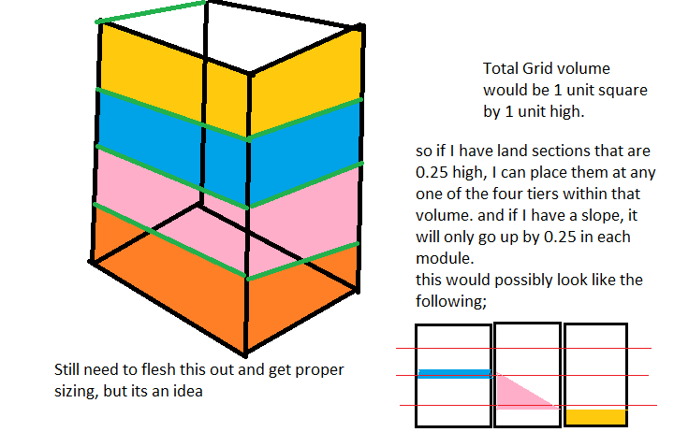

**21/03/17 (2 Hours)**

So ive made a couple of test pieces in blender, each 1x1x0.25, and ive set the proper transforms on them.

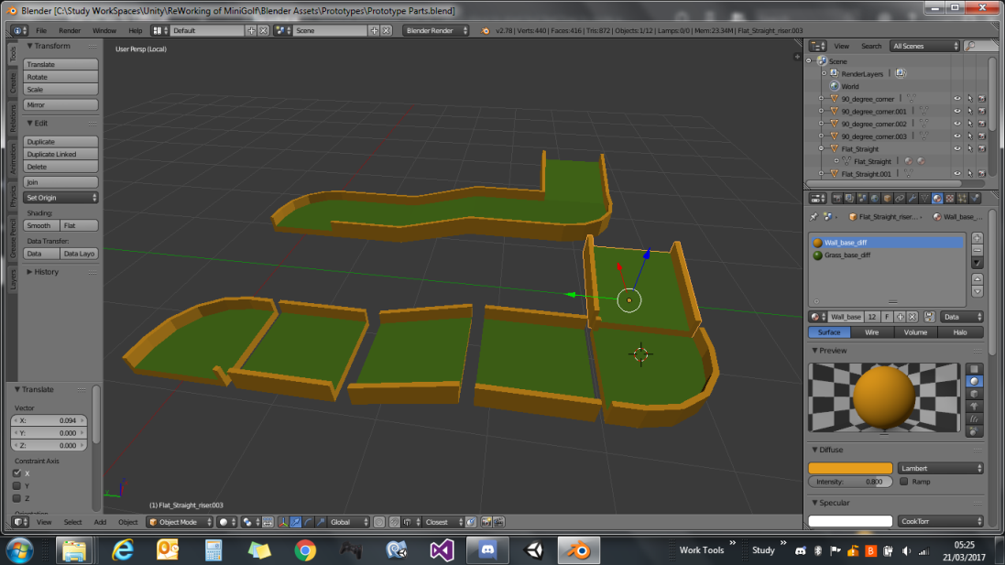

They seem to be going together half decently and all line up if they are 0.25 in height apart.

So ive exported these to FBX individually and put them into a Unity layout test scene to see how they looked, and added a mesh collider to each section and also prefabed them too as prototype parts.

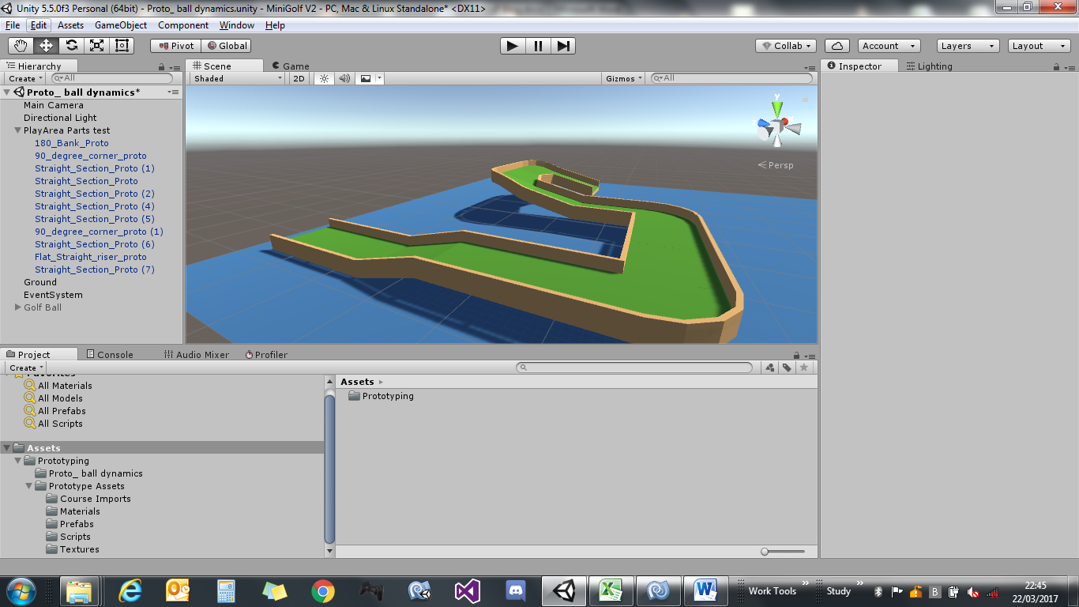

Quite happy with that, I did notice that the import settings were a 1 to 1 scale.

I applied transforms in blender to 1, exported the FBX with a 1 scale. When importing to unity they have an absolute scale of 100, need to go back and see whats up with that. Think ive forgotten something. Still looks ok tho., so that will do me for tonight I think, about 2 hours spent.

**22/03/17 (1 Hour Spent)**

So my next piece of the puzzle, I think will have to be the ball.

I think today I will have a look at how im going to get the direction to hit the ball in.

Im thinking of just using a simple arrow sprite for a direction indicator. And use raycasting to get the direction. See how that pans out over the day.

Made a little arrow in Paint.NET and exported as a PNG, then imported that into unity as a 2D sprite.

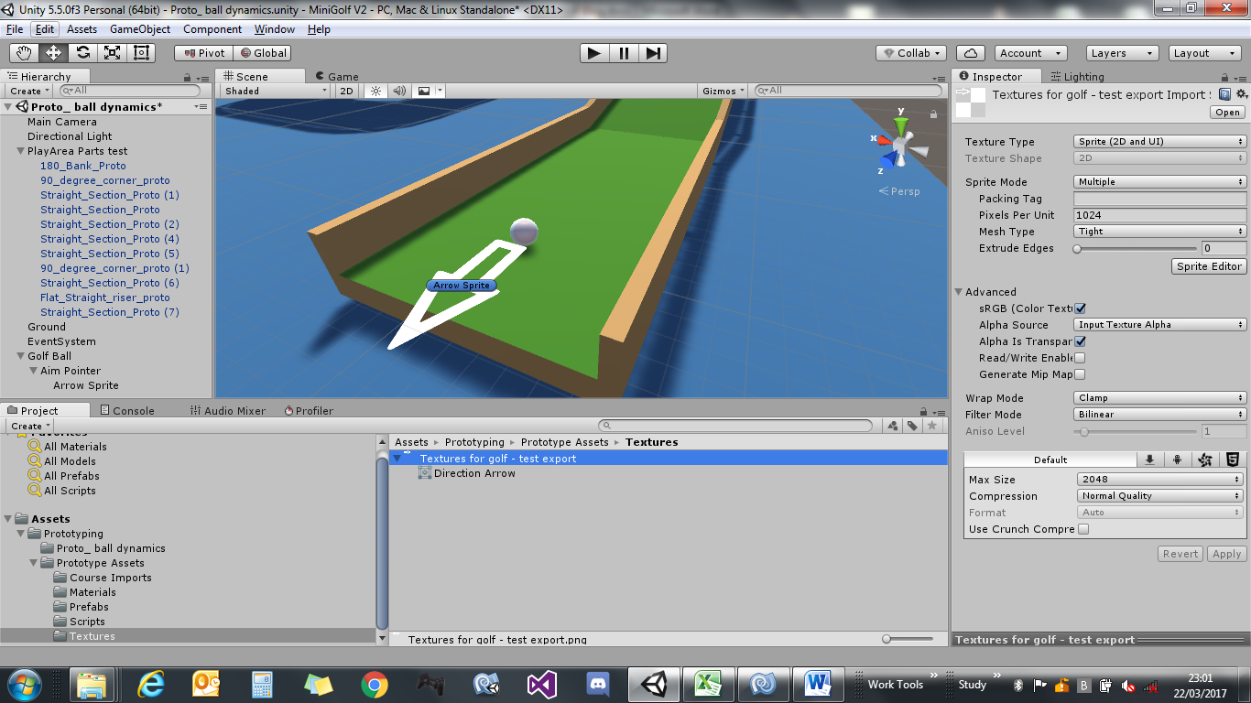

Ive put a new ball (just a unity primitive with a scale of 0.1) in the scene to test size (phew hard part done lol). I think for a sort of fun and not too serious look, this appears about right size wise.

If you look at the hierarchy there for the GolfBall, ive added a child empty ‘AimPointer’ this has the ‘Arrow Sprite’ as a child to it. Just to see how it looks. Not sure how im going to use this ‘Aim Pointer’ yet. If I leave it there, its going to just tumble around when the ball rotates since at this point the balls stationary. See how it goes later.

***Though:*** *well the ball will be stationary when taking a shot, so it might not matter too much, as its not going to be there when the ball starts rolling just need to make sure it ?? and when the ball is stationary it will be visible and always pointing in a direction . hmm*

Need to have a think, either leave it there, or try and lock the rotation to just the Z axis, but don’t know how that’s going to work on a child object.. but that’s for another day :)